Tab 2

**Gradient Decent / Forward & Backward Propagation**

**2022 Final Regular**

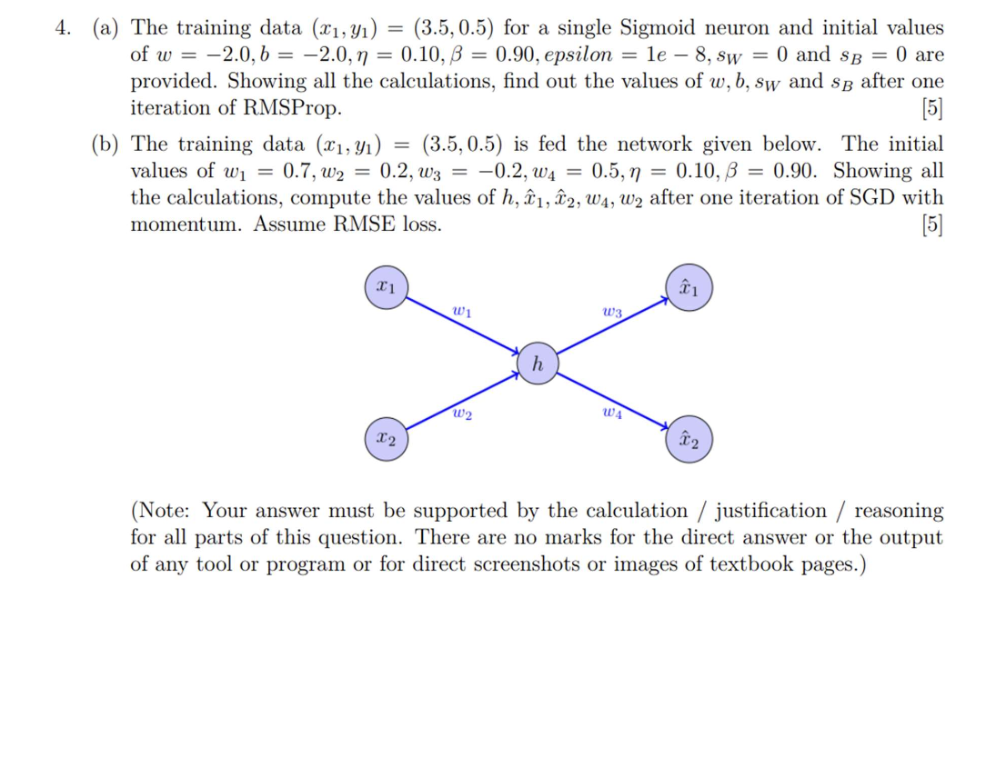

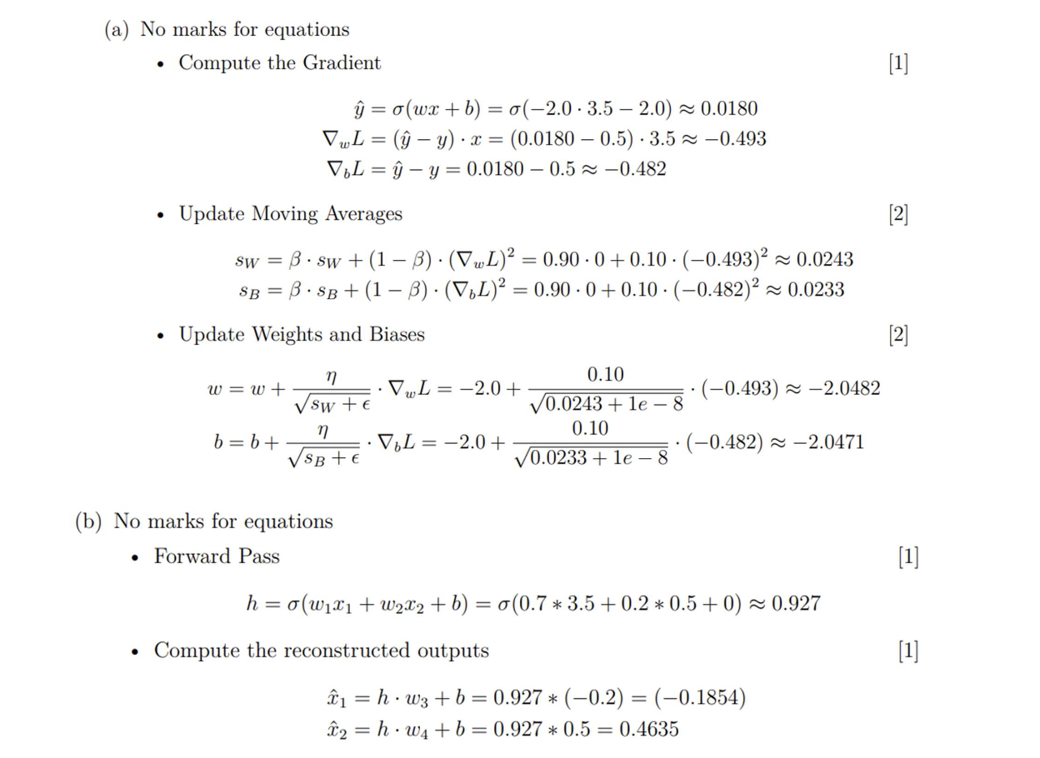

**2022 Mid Sem Makeup**

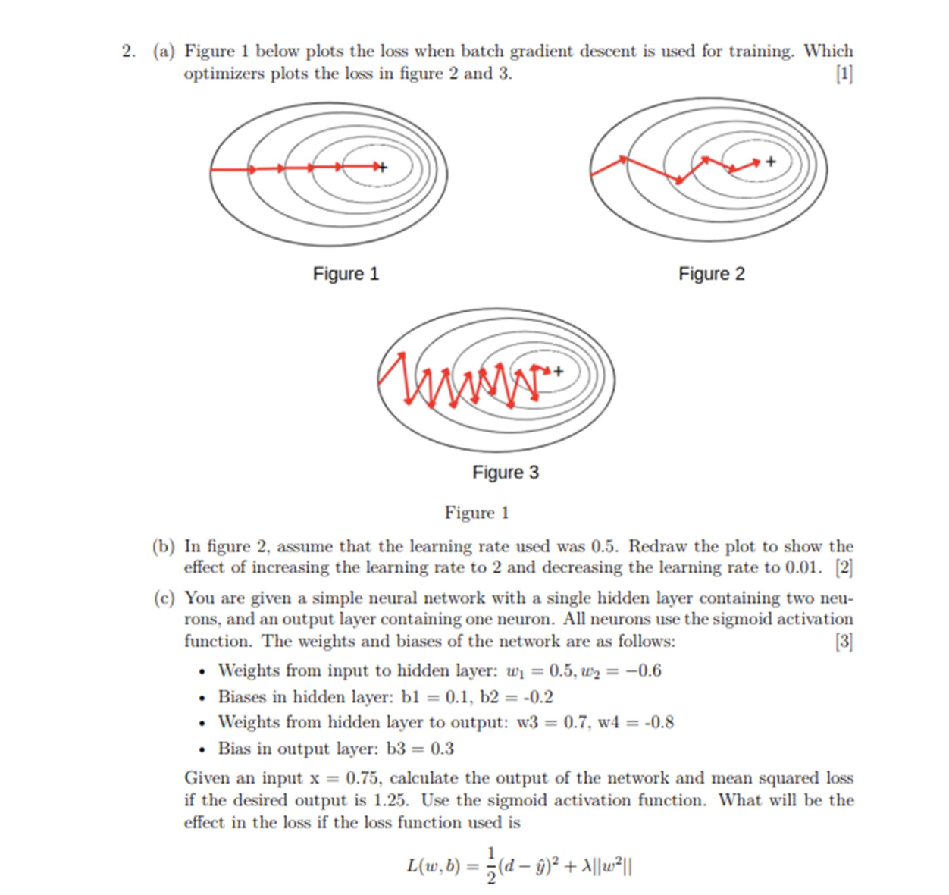

**2022 Mid Sem Makeup**

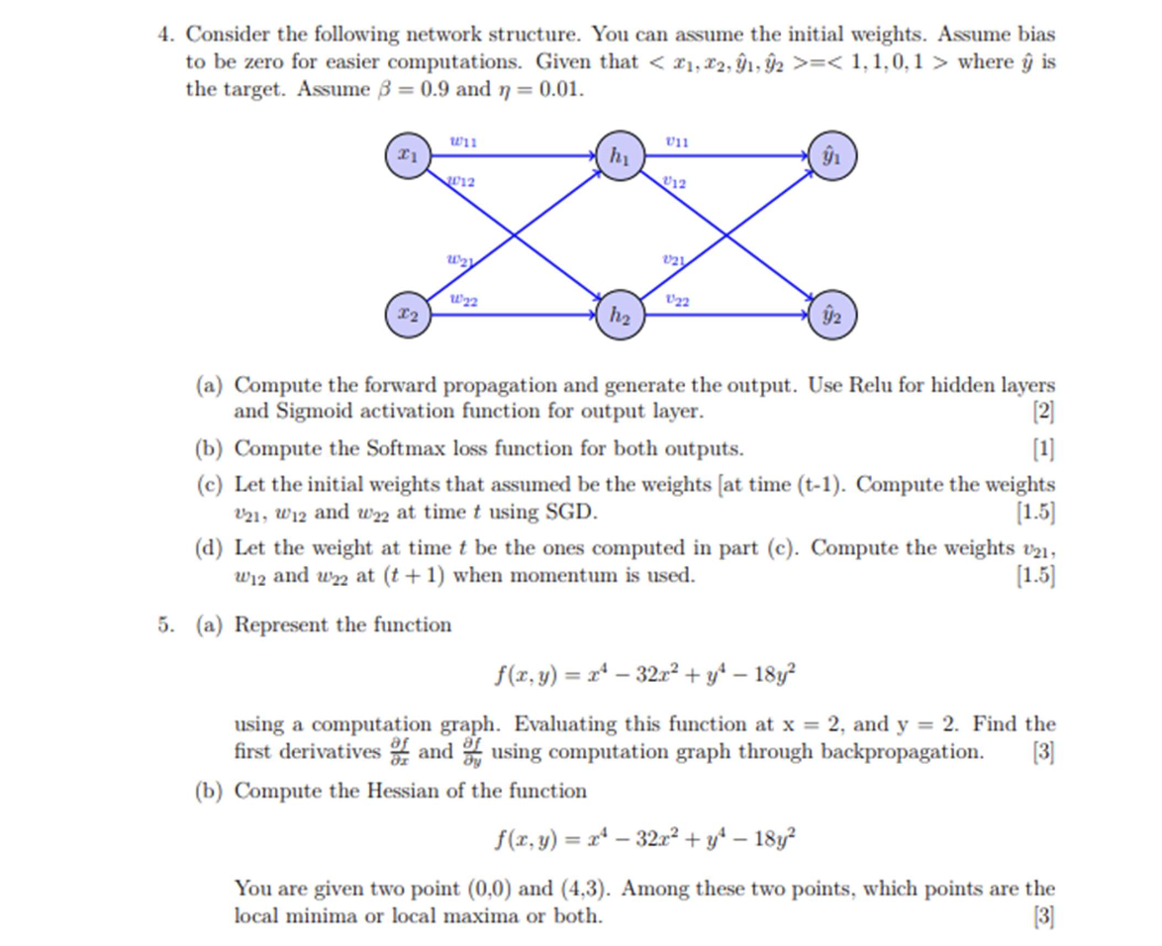

**2024 Mid Sem**

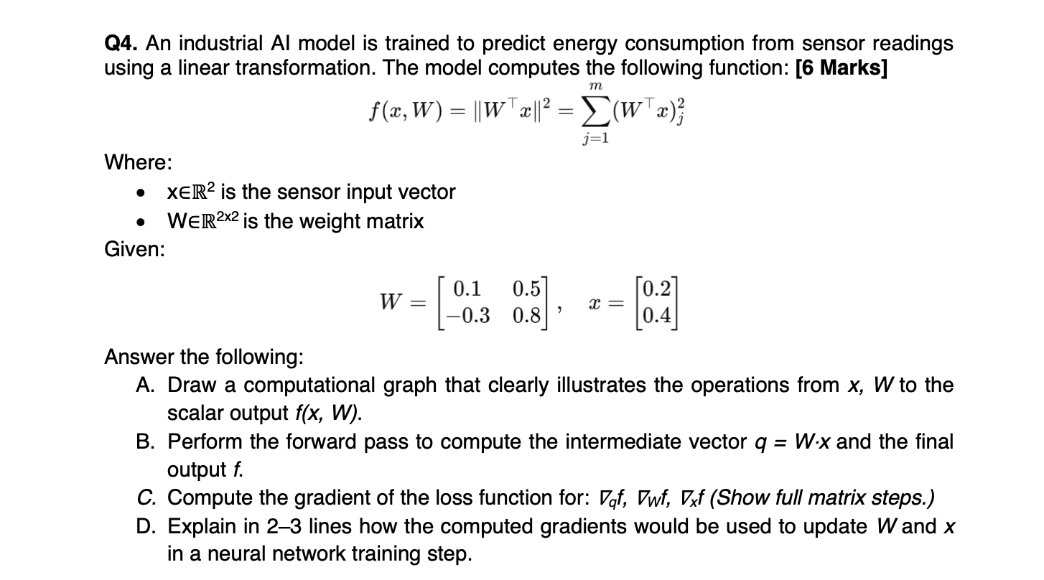

**2023 Mid Sem**

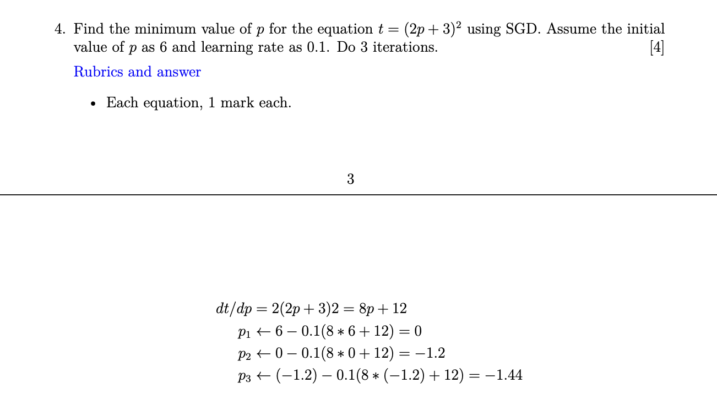

**2023 Mid Sem**

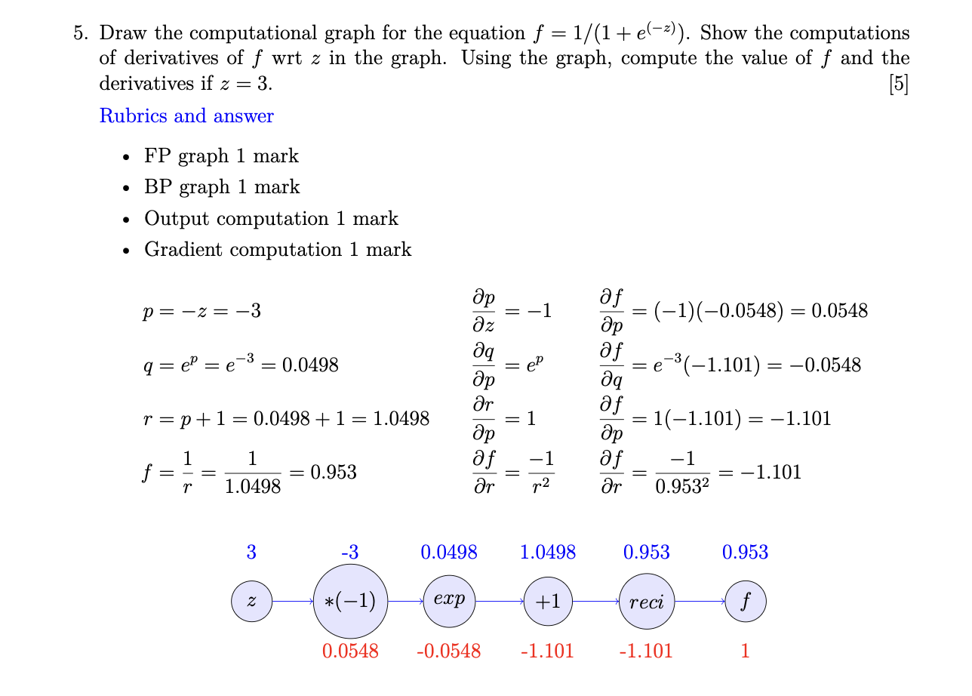

**2023 Mid Sem (Regular)**

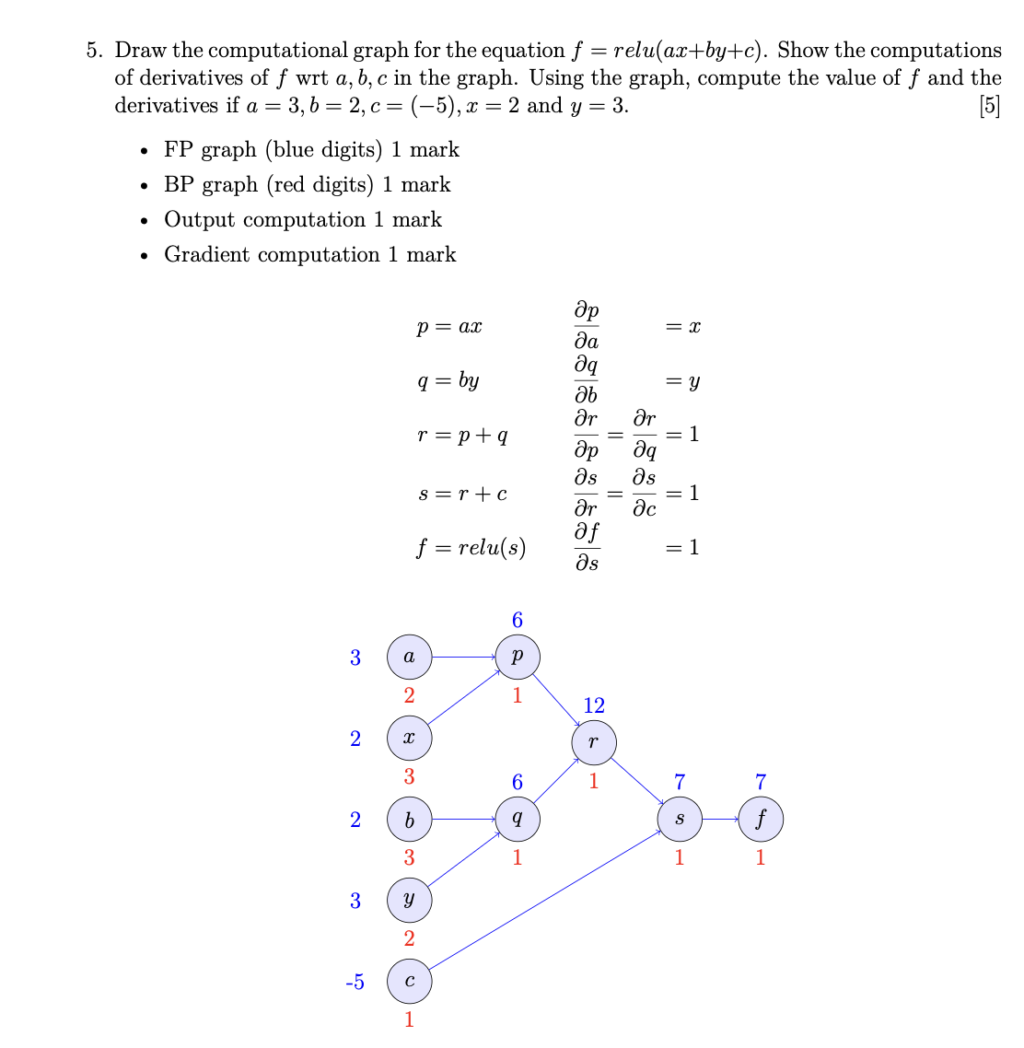

**Error functions/Minimization**

**2023 Mid Sem (Regular)**

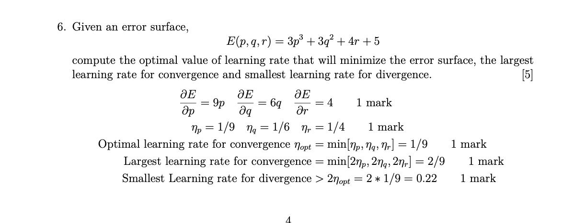

**2023 Mid Sem**

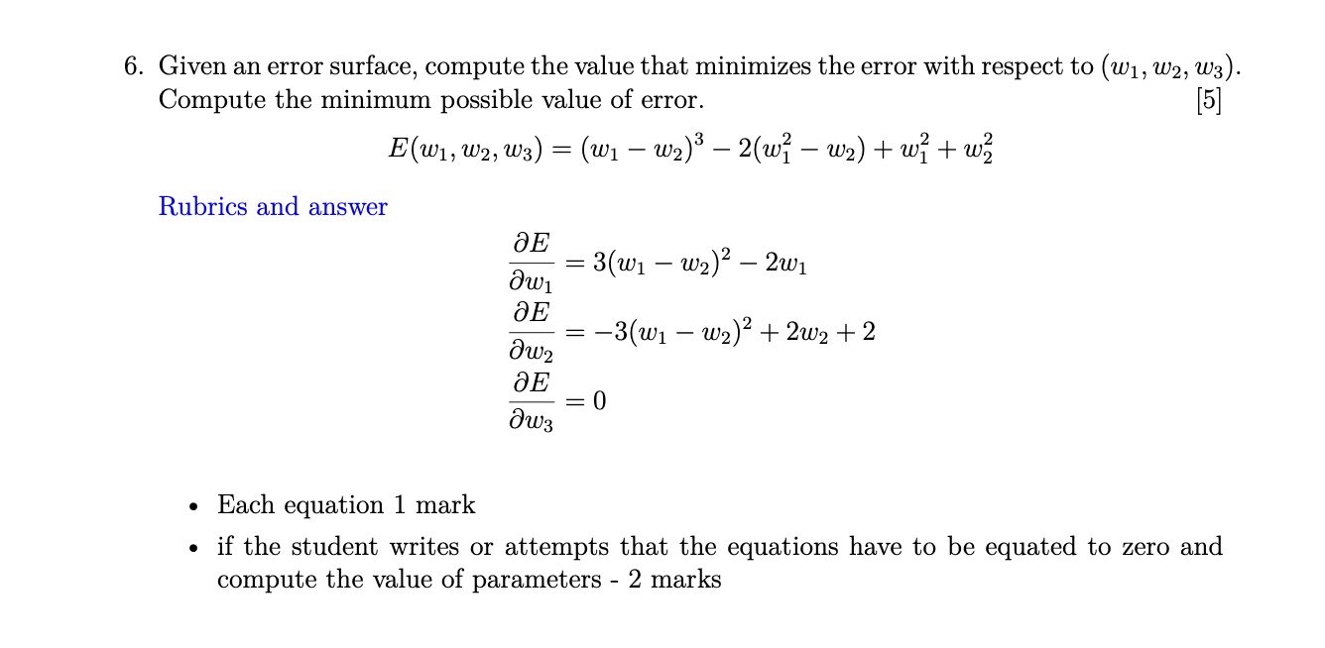

**Perceptron Learning**

**2024 Mid Sem**

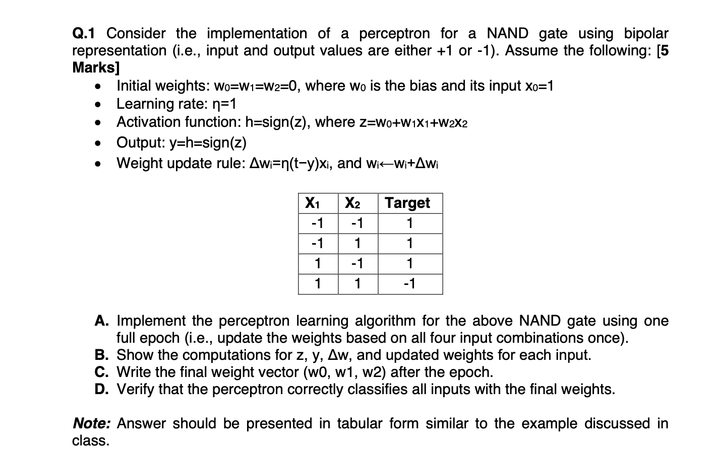

**2023 Mid Sem**

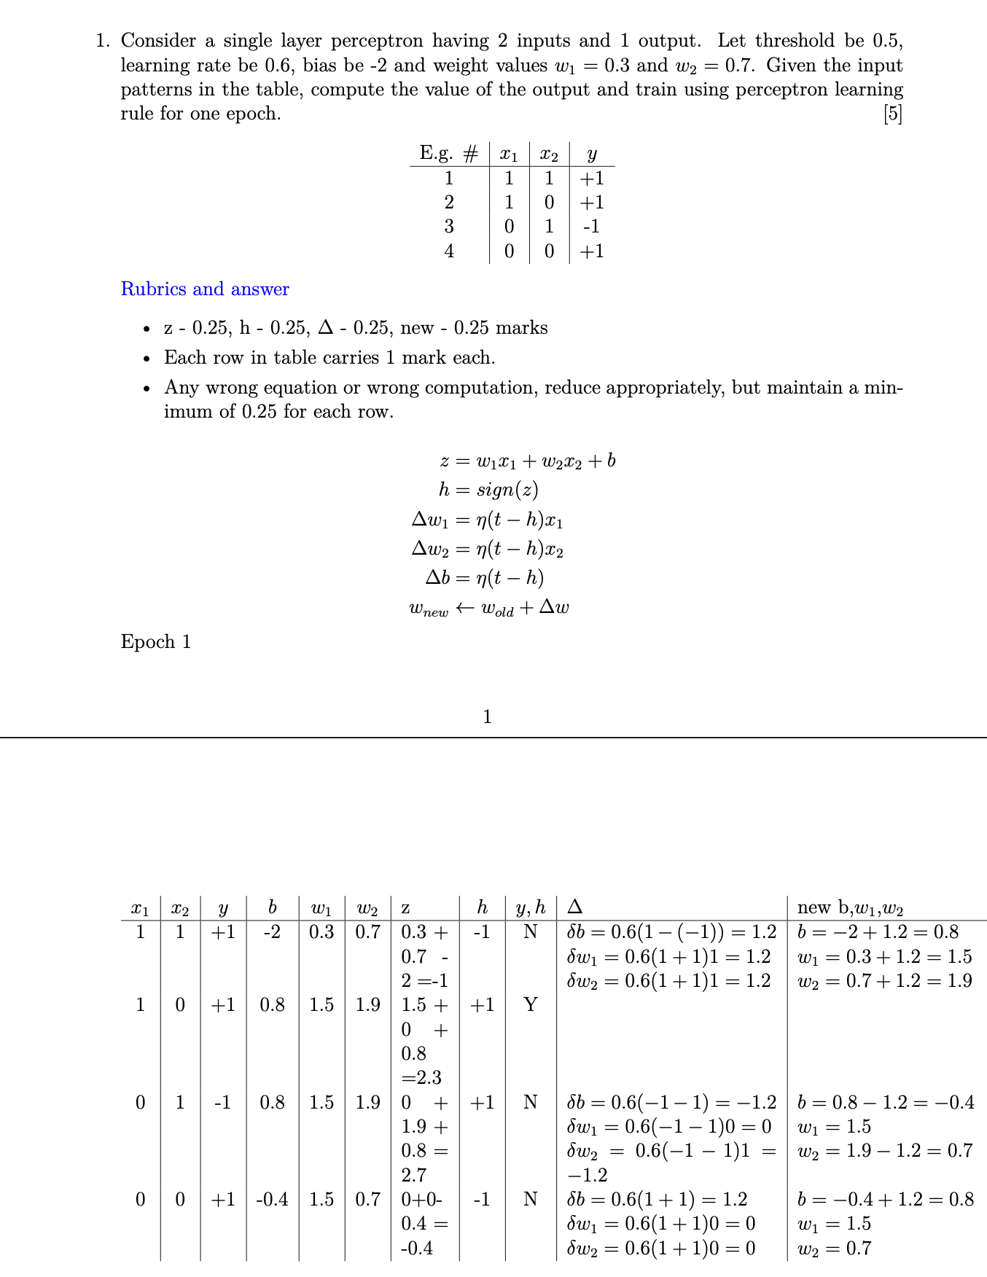

**2023 Mid Sem (Regular)**

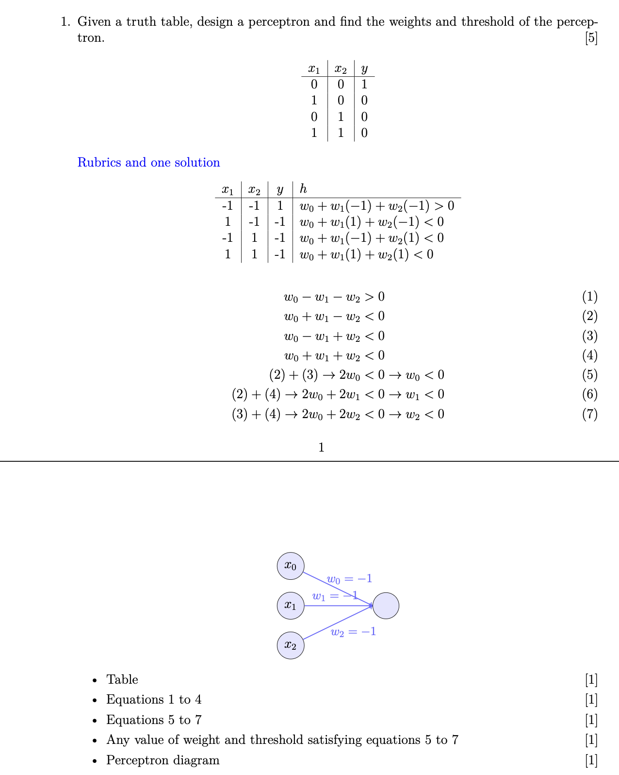

**MLP**

**2024 Mid Sem**

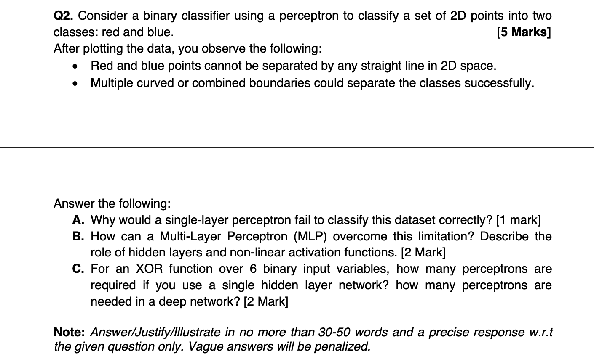

**2023 Mid Sem**

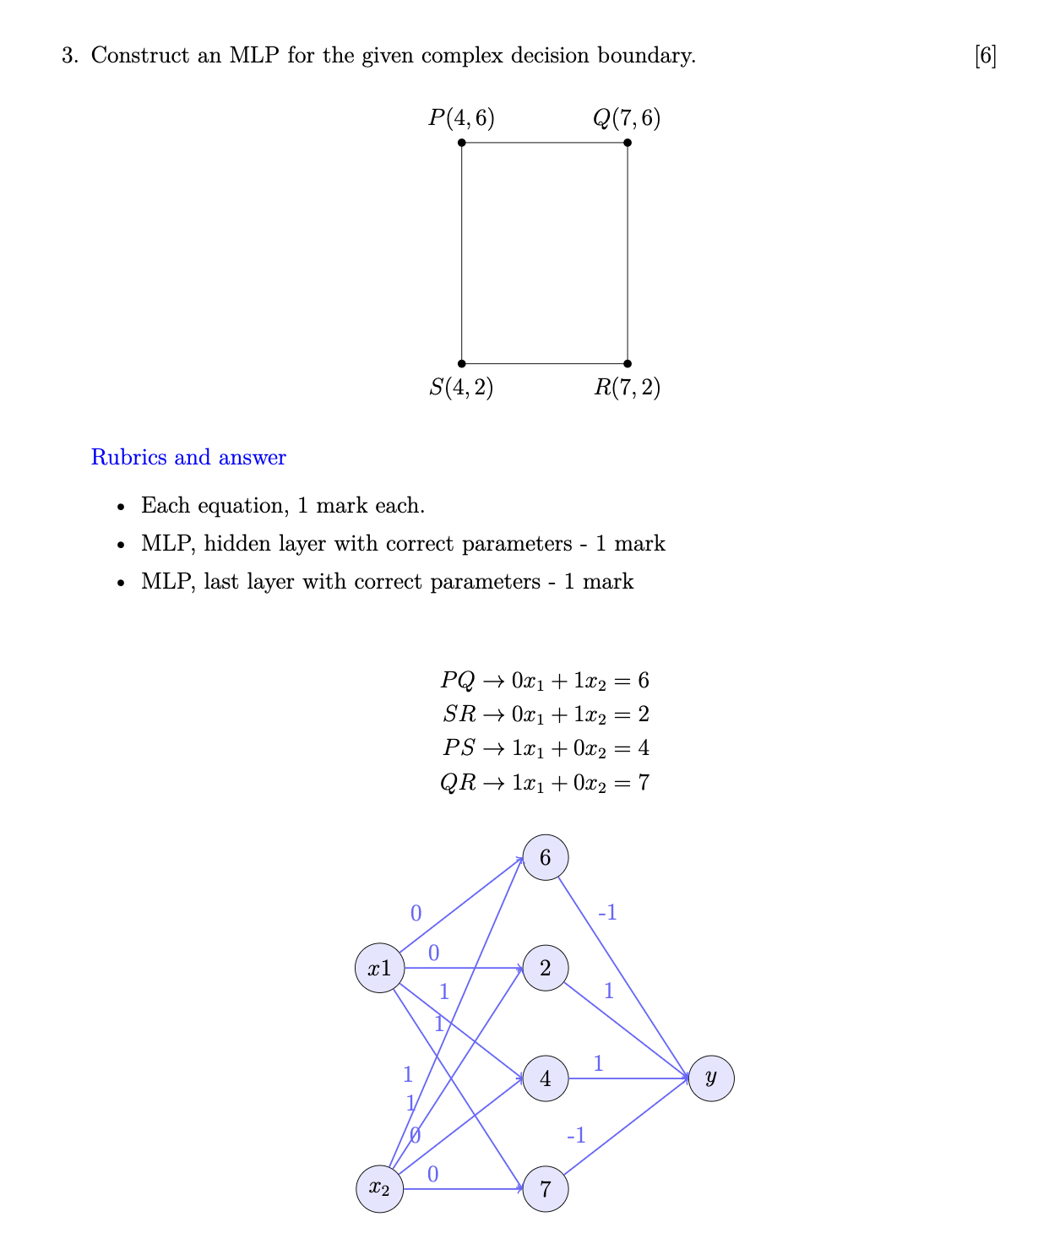

**2023 Mid Sem (Regular)**

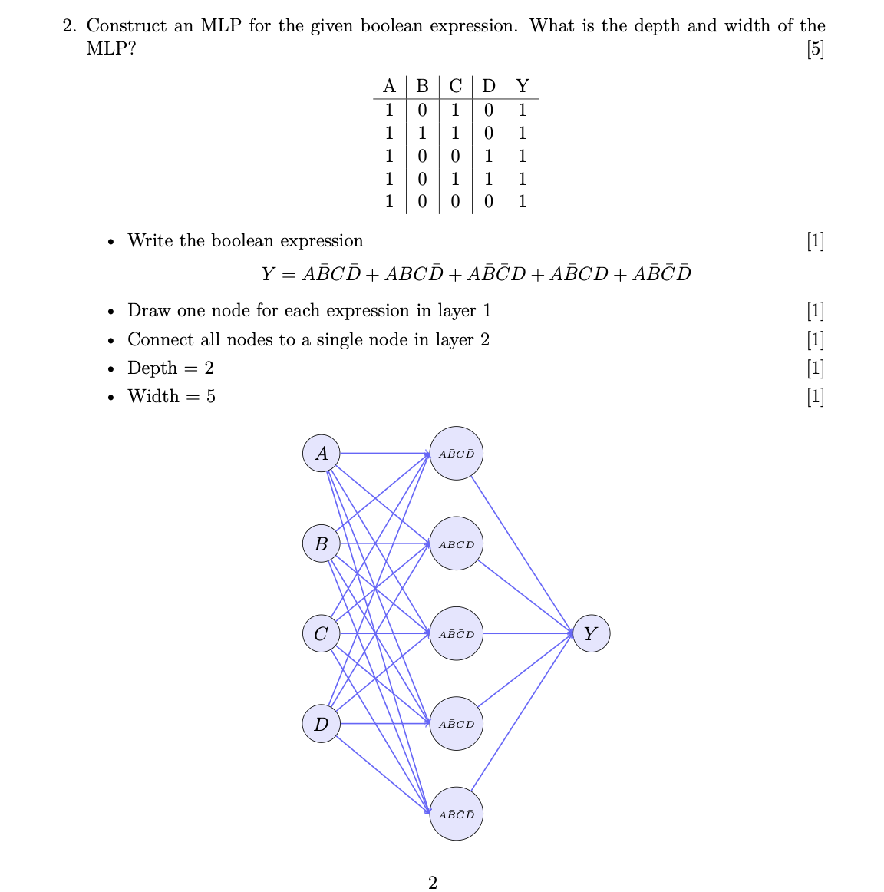

**2023 Mid Sem(Regular)**

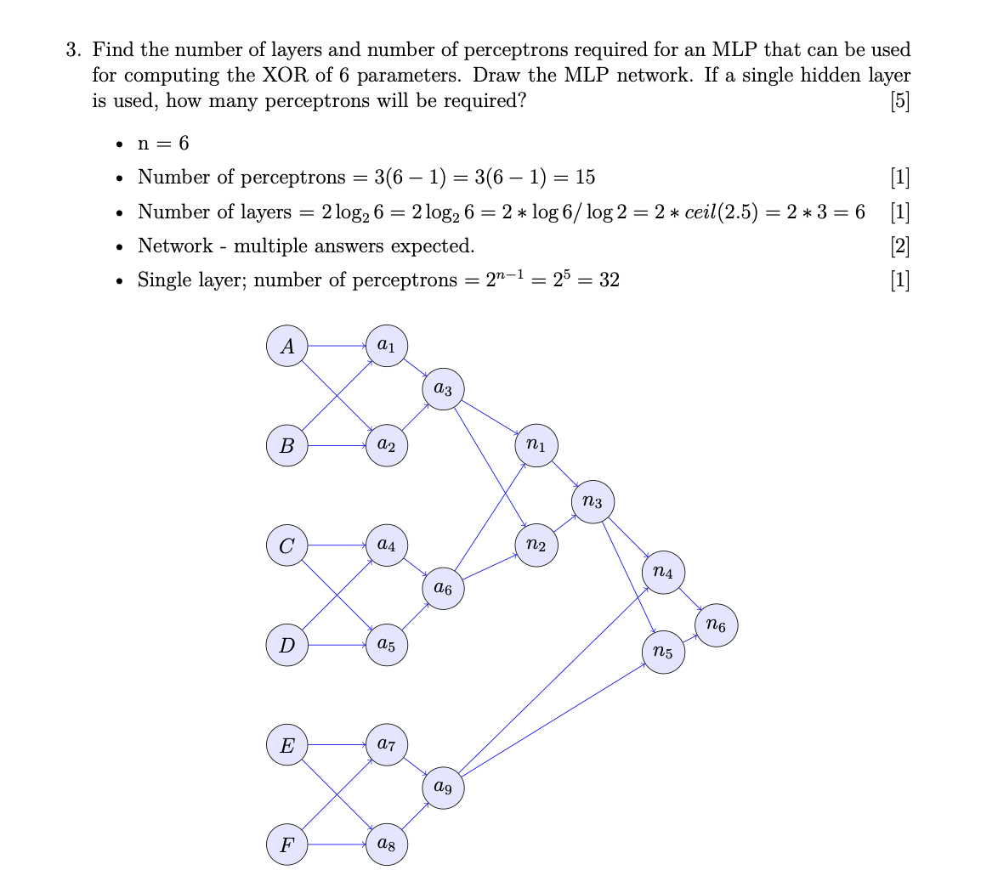

**Loss Functions**

**2024 Mid Sem**

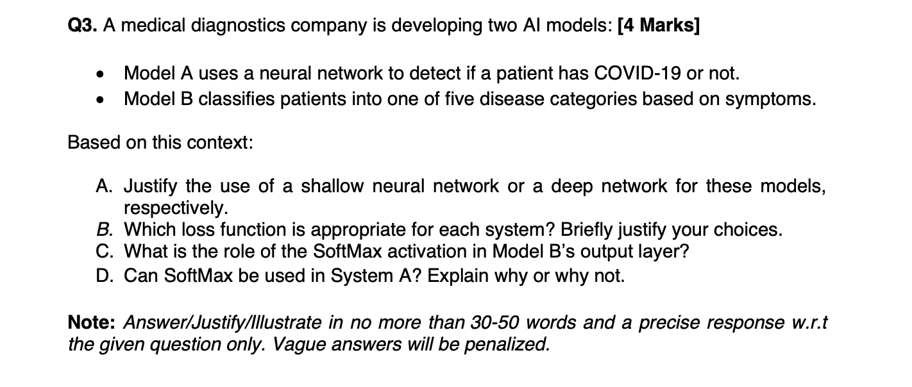

**2023 Mid Sem**

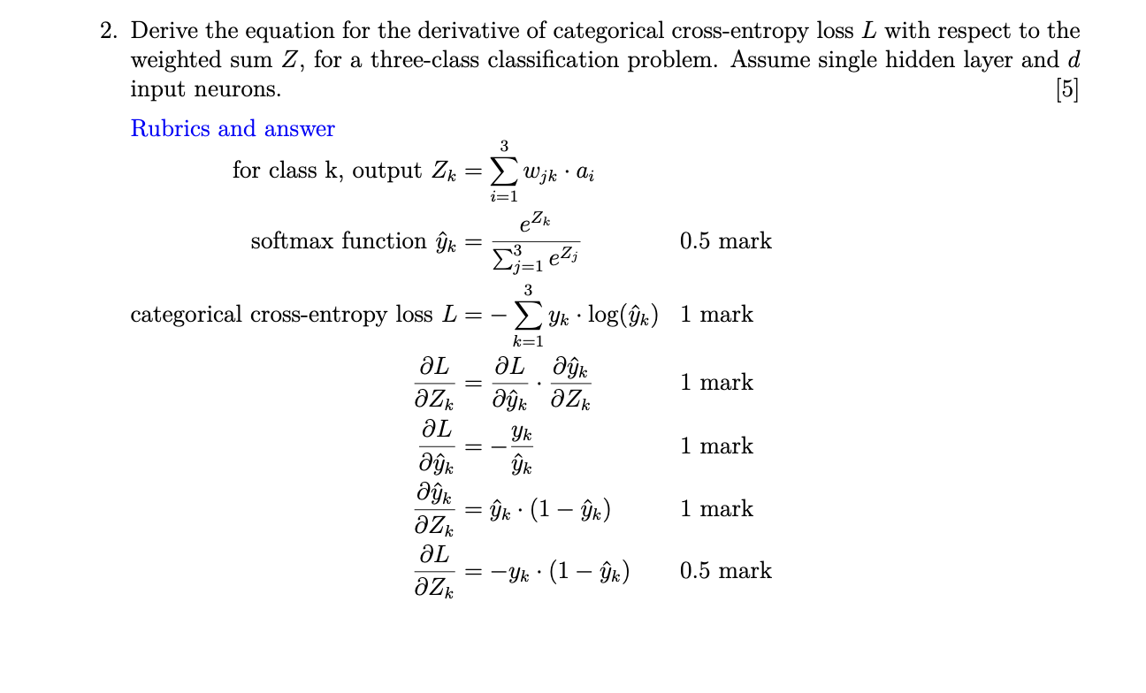

**2023 Mid Sem (Regular)**

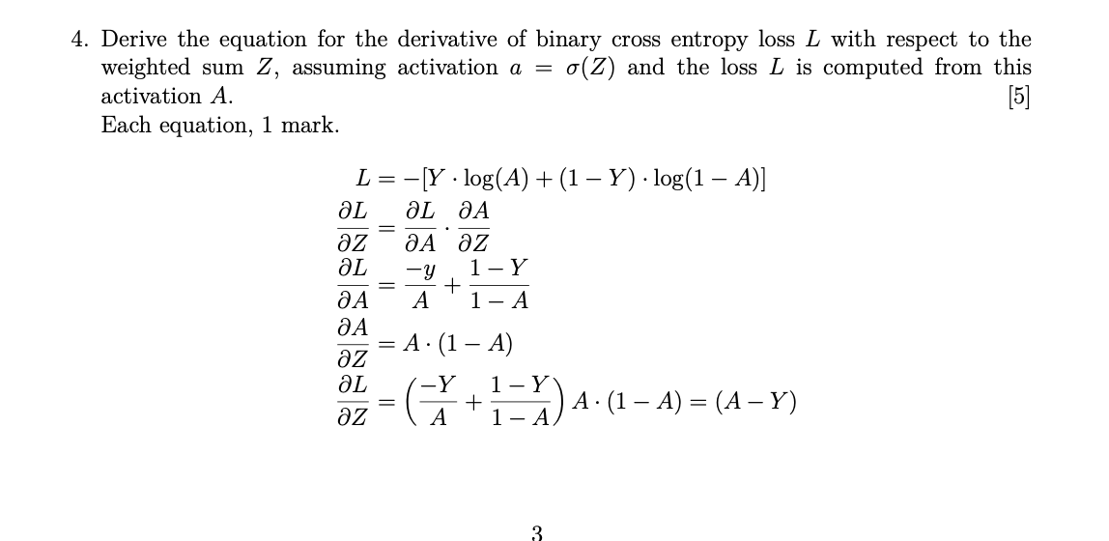

**Deep Learning Training**

**2024 Mid Sem**

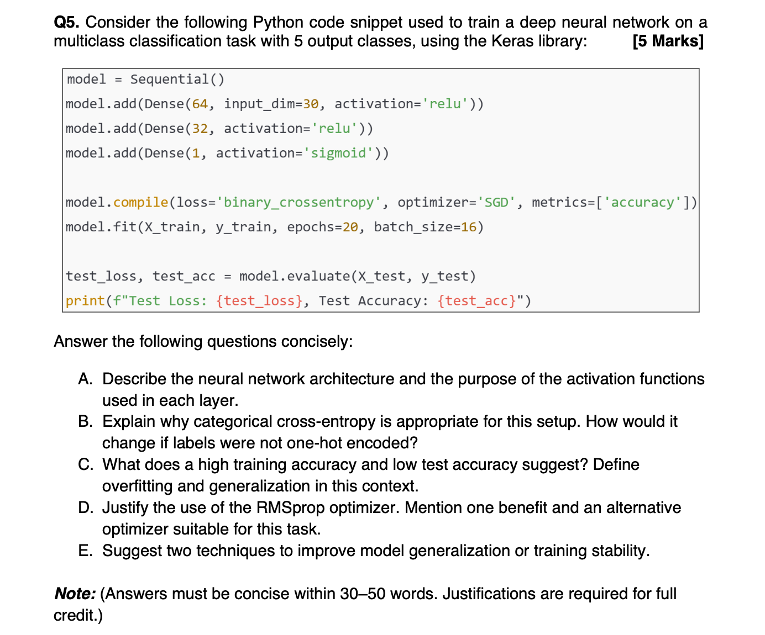

**Parameter Couting**

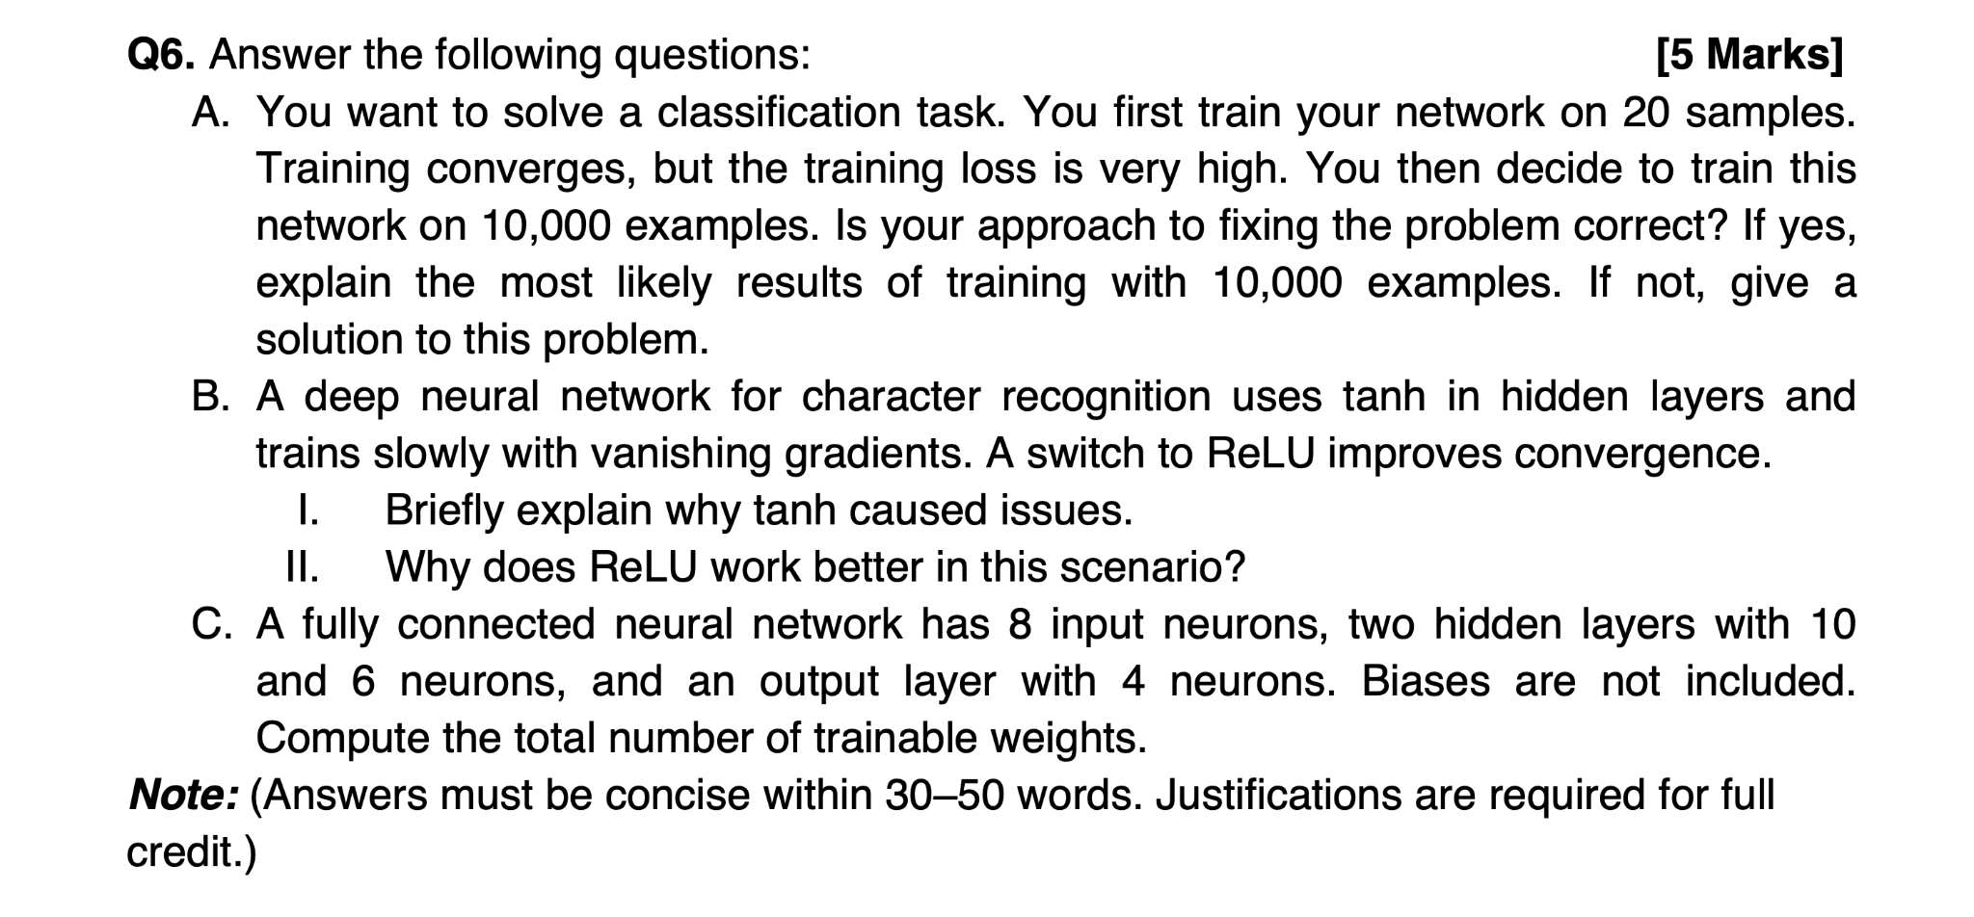

**2022 Mid Sem Makeup**

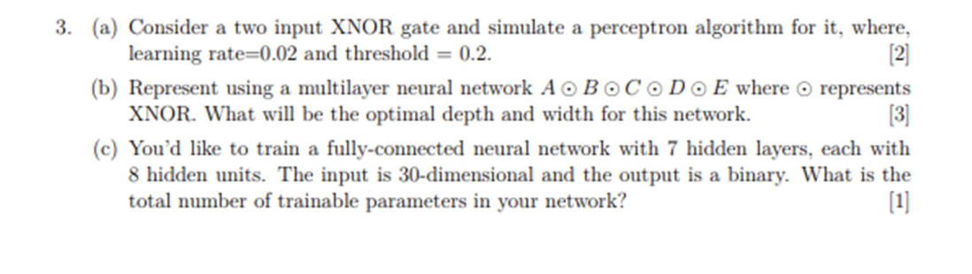

**Neural Network Architecture & Training Setup**

**2022 Mid Sem**

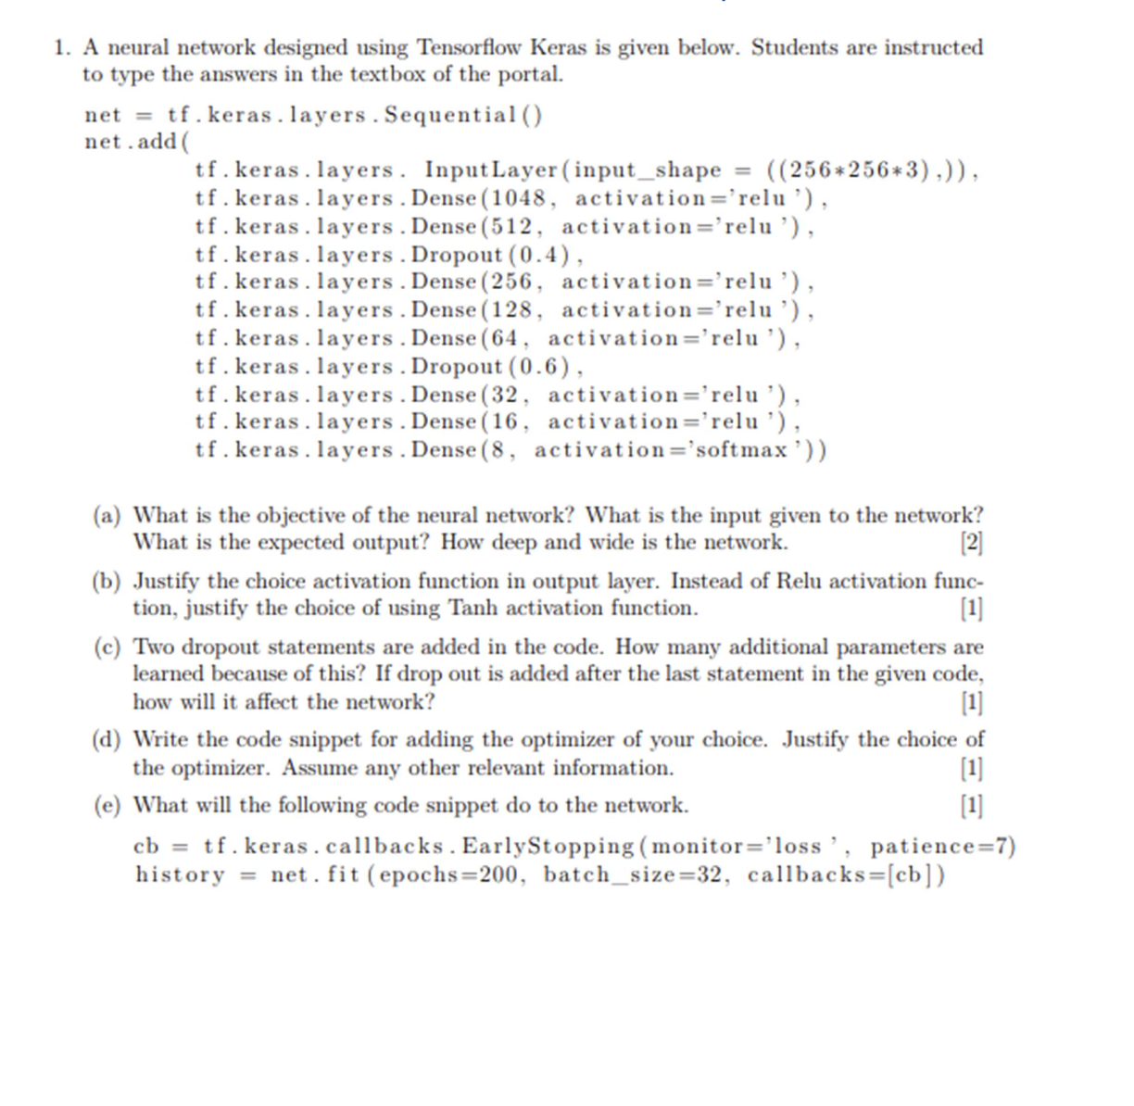

**2022 End Sem**

